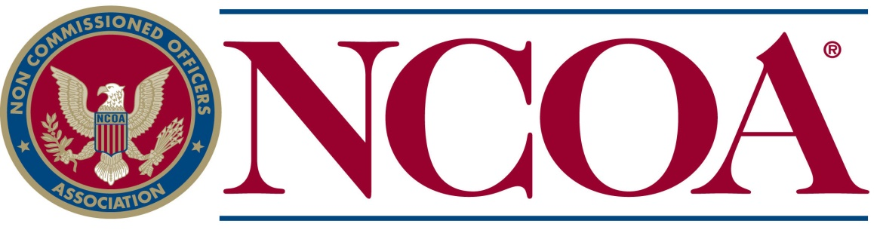 Rogue Chapter Scholarship Application

Applicant is: ⃝ the son, daughter or grandchild of an NCOA member OR ⃝ .son, daughter or grandchild of an honorably discharged veteran.
A. PERSONAL INFORMATION
1. Name______________________________________________2. Age_____3. Date of Birth_____________
4. Social Security Number___________________________ 5. Sex__________ 6. U. S. Citizen? ⃝ Yes ⃝ No
7. Parents’/Spouse’s Branch of Military Service and Rank __________________Dates Served_______________
8. Parents’/Spouse’s NCOA Membership Number or a DD-214 (REQUIRED) _____________________________
9. Address (street)___________________________________________________________________________
10. Address (city, state, Zip)____________________________________________________________________
11. Telephone Numbers (home)____________________________( cell)________________________________
12. E-mail__________________________________________________________________________________
13. This will be my ⃝ 1st ⃝ 2nd ⃝ 3rd ⃝ 4th year of undergraduate study or trade school.
B. EDUCATION INFORMATION
1. High School or GED______________________________2. Date graduated or will graduate______________
3. Extracurricular: __________________________________________________________________________
________________________________________________________________________________________
________________________________________________________________________________________
4. Hobbies: ________________________________________________________________________________
________________________________________________________________________________________
________________________________________________________________________________________
5. Sports activities: _________________________________________________________________________
________________________________________________________________________________________
________________________________________________________________________________________
6. Field of study (desired trade):______________________________________________________________
________________________________________________________________________________________

This is a my ⃝ 1 year ⃝ 2 year ⃝ 3 year ⃝ 4 year study or trade program.
7. Name and address of the college, university or trade school you plan to attend: _______________________
________________________________________________________________________________________
C. PUBLICITY INFORMATION
1. Home town newspaper or other media: ______________________________________________________

2. Address: _______________________________________________________________________________
________________________________________________________________________________________
3. Names of parents or spouse: _______________________________________________________________
4. Address of parents or spouse _______________________________________________________________
5. Local high school attended: ________________________________________________________________
E.CERTIFICATION
I understand that academic or trade school scholarships are awarded for undergraduate study only..
I understand that only individuals selected to receive scholarships will be notified.
___________________________________________________ _____________________________________
Signature Date

Deadline for submission of application is May 15 of each year.

Rev. 12/18

Instructions to Scholarship Applicants

The information you furnish will aid in determining the grant of a scholarship. You May be requested to furnish additional data for consideration. All scholarship applications must be submitted with all related documents attached. Applications received without required documents will not be considered by the Scholarship Selection committee.

Checklist for Sons, Daughters or grandchildren of NCOA Members
⃝ Completed application.
⃝ Two letters of recommendation from your
school, i.e. principal, counselor/vocational
director, teacher of your choice.
⃝ Autobiography in your own handwriting.
⃝ A personal letter of recommendation from an
adult who is not a relative.
⃝ A certified transcript of your high school or
college grades-depending on which currently
attending.
⃝ The NON Commissioned Officers Association is
a patriotic organization; therefore, the
applicant is required to submit a composition
on Americanism (consisting of not less than
200 words).
⃝ Only those selected to receive scholarships
will be notified. If you would like to receive
the list of scholarship recipients, please
include a self-addressed stamped envelope.
⃝ Keep a duplicate of all documents submitted.

Checklist for sons, daughters or grandchildren of veterans
⃝ Completed application.
⃝ A copy of the DD-214 of the sponsoring veteran parent or grandparent.

⃝ Two letters of recommendation from your
school, i.e. principal, counselor/vocational
director, teacher of your choice.
⃝ Autobiography in your own handwriting.
⃝ A personal letter of recommendation from an
adult who is not a relative.
⃝ A certified transcript of your high school or
college grades-depending on which currently
attending.
⃝ The NON Commissioned Officers Association is
a patriotic organization; therefore, the
applicant is required to submit a composition
on Americanism (consisting of not less than
200 words).
⃝ Only those selected to receive scholarships
will be notified. If you would like to receive
the list of scholarship recipients, please
include a self-addressed stamped envelope.
⃝ Keep a duplicate of all documents submitted.

Mail ALL information in ONE COMPLETE package to:
Rogue Chapter #1260 NCOA
P.O. Box 5597
Central Point, OR 97502

